For Immediate Release Media Contact: Karen Gross
June 7, 2018 Suasion, LLC
717.432.2468
Karen@Suasion.us

AHEDD Welcomes New President
Rocco Cambria retires after 41-year career at statewide disability employment organization

Camp Hill, Pa. (June 7, 2018)– Today, AHEDD announced the appointment of Brandy F. Burnham to President of the private, non-profit organization which was founded in 1977 to meet the employment needs of people with disabilities and the business community. Burnham, who began her tenure on June 4, 2018, succeeds Rocco Cambria whom held the position since 1983 and was instrumental in founding the organization 41 years ago.

“Although it is difficult to imagine not being deeply involved in an organization that I have spent most of my career leading, I look forward to retirement and couldn’t be more excited and optimistic about what the future holds for AHEDD under fresh leadership,” Cambria said. “Brandy joins the organization as a dynamic, talented and versatile senior-level executive and industry trailblazer who is passionate and committed to AHEDD’s mission and the people we serve.” Brandy F. Burnham

A graduate of Pennsylvania State University and Harrisburg Area Community College, Burnham began her career as a support teacher and behavior specialist at Forbush School where she taught critical skills in the areas of academics, vocational preparation, social skills and behavior management. Her career path, which includes years of learning and case management support for students, youth and adults with disabilities, led her to several positions with the state’s Department of Labor & Industry. For more than five years, she held the position of Director of the Bureau of Workforce Development Administration where she cultivated dynamic relationships with federal, state and local constituents.

“We are pleased, after an intense national search, to welcome Brandy as the next President of AHEDD,” Keith D. Mitchell, AHEDD’s Chairman of the Board of Directors, said. “Her background in fundraising; policy administration; strategic planning; mental health; and special education uniquely qualifies her to successfully navigate the evolving environment of workforce development under the Employment First priorities.”

According to Burnham, it was the mission of AHEDD, which aligned with her background and passion, that drove her desire for the position.

“Meaningful, integrated employment for people with all types of disabilities changes lives and expands the diversity, inclusion and prosperity of our state,” Burnham explained. “AHEDD is a leader in the industry and has successfully connected thousands of people with disabilities to Pennsylvania employers who are benefiting from their skills and talents. I look forward to working with this incredible, performance-driven team to continue the legacy Rocco and others have created to achieve success as we move into the future.”

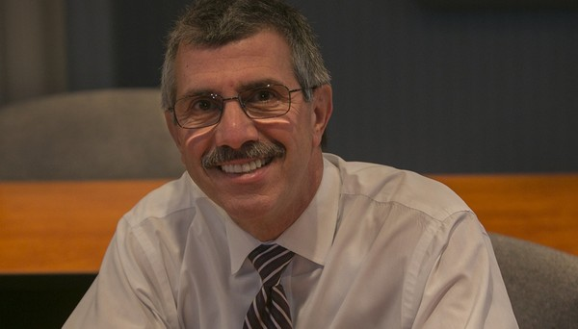
Cambria’s official retirement date is slated for July 6, 2018. In addition to his 41-year career at AHEDD, Cambria has served on state policy planning committees and councils through which he has expanded services to people with disabilities in our state. He has provided organizational consulting and technical assistance to organizations in five U.S. states and conducted statewide training workshops and seminars addressing topics of job readiness, development, placement and training of individuals with disabilities. Prior to AHEDD, Cambria worked at the Pennsylvania ARC, directing the statewide On-The-Job Training program while coordinating training and employment activities.
Rocco Cambria

“Rocco has played an integral role in expanding employment opportunities for individuals with disabilities in our state for more than four decades,” Mitchell said. “His dedication to this mission has been consistent and unwavering. The AHEDD Board, leadership team and staff across Pennsylvania wish him a well-deserved, enjoyable retirement as we look forward to the next chapter in our organization’s history.”

# # #

About AHEDD
Founded in 1977, AHEDD is a private, non-profit organization assisting businesses in hiring and training qualified people with disabilities. Based in Camp Hill, PA, AHEDD employs more than 70 individuals across Pennsylvania through a network of field offices. The organization serves communities as a catalyst in the employment and development of people with disabilities. Additional information may be found at http://www.ahedd.org | Twitter: http://twitter.com/AHEDDATWORK | Facebook: www.facebook.com/AHEDDATWORK/ |

