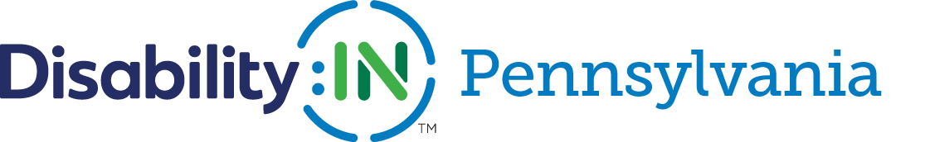
ADA CELEBRATION 2020
TAKE AWAY PIECE

- Stacy Kyle, Director of Disability:IN PA

  - AHEDD ( www.ahedd.org ) currently coordinates Disability:IN Pennsylvania as a Business Project of the organization

  - 866-902-4333 ext. 90115

  - stacy.kyle@di-pennsylvania.org

  - LinkedIn Profile- https://www.linkedin.com/in/stacy-kyle-9a110011/

  - Disability:IN Pennsylvania Website- www.di-pennsylvania.org

- Disability:IN Pennsylvania’s Advisory Board Members

  - Mike Park, CAI- https://www.linkedin.com/in/michaelbpark/

  - Michelle Staton, Pennsylvania Bankers Association-https://www.linkedin.com/in/michelle-staton-mba-48569118/

  - Cathy Rychalsky, Workforce Development Board Lancaster County- https://www.linkedin.com/in/cathy-rychalsky-3a92b217/

  - Anubhav (Anu) Kochhar – Deloitte Tohmatsu Consulting LLC- https://www.linkedin.com/in/anubhav-kochhar-81076544/

  - Duane Rohr, CVS Health- https://www.linkedin.com/in/duane-leo-rohr-4578b278/

  - Janet Fiore, The Sierra Group- https://www.linkedin.com/in/janetfiore/

  - Shane Franklin, Starbucks

- NEXTGEN LEADERS

  - What is the NextGen Leader program? https://disabilityin.org/what-we-do/nextgen-leaders-initiatives/

  - NextGen Business Mentor highlighted on July 14th- Nancy Scaffa- Bristol-Myers Squibb- https://www.linkedin.com/in/nancyscaffa/

  - Resume Database- look up the candidates highlighted on July 14th and those from other states- https://resumedatabase.disabilityin.org/

- PA NEXTGEN LEADERS HIGHLIGHTED ON JULY 14th

  - Haley Kerman - https://www.linkedin.com/in/haley-kerman/

  - Keara Mangan- https://www.linkedin.com/in/kearamangan/

  - Rashi Wathore- https://www.linkedin.com/in/rashi-w-664804159/

  - Eric Baker- https://www.linkedin.com/in/elb5465/

  - Matthew Nick Gomberg- https://www.linkedin.com/in/nick-gomberg/

  - Kelvin Isom II- https://www.linkedin.com/in/kelvinisomii/

  - JooYoung Seo- https://www.linkedin.com/in/jooyoungseo/

- WRAP UP AND LINKS

  - https://resumedatabase.disabilityin.org/

  - Here are a few stories submitted by our Advisory Committee that can help you expand knowledge and understanding in your workforce:

    - CAI- https://www.dropbox.com/sh/cryjgvs0izsjv3g/AADukvOqkdj06vN4nz1I0-_Oa/H264%20(Burned%20in%20Captions)?dl=0&preview=A2W+-+SHORT+1b+-+Candidate+-+Saras_Story+-+SUBTITLES.mp4&subfolder_nav_tracking=1

    - CVS Health- https://vimeo.com/dncinematics/review/386015718/5bbdf52dbb

    - The Sierra Group - https://youtu.be/HtFWsJn9xNE

  - Finally….As we celebrate the ADA, we can’t totally ignore the impact of COVID on the current employment situation for people with disabilities. Nationally there was a 20% reduction in employment for pwd between March and April compared to a 14% decrease for those individuals without disabilities. There are also some challenges regarding RTW with new duties/processes, employers who are difficult to reach, gaps for PCA needs, working from home adjustments, etc.

A future Tuesday Talk could give more attention to this topic. In the meantime, you could check out the following links:

    - RESEARCH from beginning of MAY-https://researchondisability.org/news-features/2020/05/08/ntide-april-2020-jobs-report-covid-recession-hits-workers-with-disabilities-harder . It includes data from Bureau of Labor Statistics which reports that nationally there was a 20% reduction in employment for pwd between March and April compared to a 14% decrease for those individuals without disabilities. There are definitely some challenges for some regarding RTW with new duties/processes, employers who are difficult to reach, PCA needs, working from home, etc.

    - The following is a link to a webinar which was hosted on May 15th by the Association of University Centers on Disability, University of New Hampshire, Rehabilitation and Research Training Center on Employment Policy and Measurement…. https://researchondisability.org/ntide

